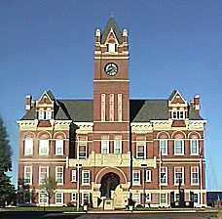

Thomas County Board of Commissioner’s Agenda
Subject to change
Monday, November 30, 2015 - 9:00 a.m. – noon

Meeting called by: Commissioner Paul Steele
Attendees: Commissioners Steele, Baughn, and Sowers; Linda Sowers; and County Clerk Shelly Harms; Pete Langer; Jerry Michaud; and County Treasurer Layn Bruggeman

9:00 a.m.  9:00 a.m. – 9:15 a.m.  9:30 a.m. – 9:45 a.m.  9:45 a.m. – 10:00 a.m.  10:00 a.m. – 10:15 a.m. | New and Old Business  - Call Commission meeting to order  - Agenda  - Langer Industrial: Landfill proposition  - DSNWK Annual Report, Cost of Services report, and Case Histories: Jerry Michaud  - Treasurer’s wage proposal for 2016: County Treasurer Layn Bruggeman  - Sealed Bids on Acquisition of Property  Action Required  - AP Payment Register(s)  - Approve Monday, November 16 Commission minutes  - Approve November payroll  - Sheriff credit cards $3,542.96 missing receipts  - Tax Roll Correction(s) with some due to USD 275 incorrect levies certified  - 2016 Wages  - Purchase copier/scanner/fax – Clerk’s office  - Inventory – Direct Election, Commissioners, and Clerks  Miscellaneous Business (no action required)  - Reports: Economic Development, Emergency Management  - EMS taking possession of medications from Law Enforcement Center

